UNO code-

int temppin=0;

float temp;

void setup()

{ Serial.begin(9600); }

void loop()

{

temp=analogRead(temppin); // Reading data from the sensor.This voltage is stored as a 10bit number

temp=(5.0*temp*1000.0)/(1024*10);

/* 5*temp/1024 is to convert the 10 bit number to a voltage reading.

This is multiplied by 1000 to convert it to millivolt.

We then divide it by 10 beacuse each degree rise results in a 10 millivolt increase. */

Serial.println(temp);

delay(1000);// This is because we dont want a continuous stream of data

}

Circuit Diagram

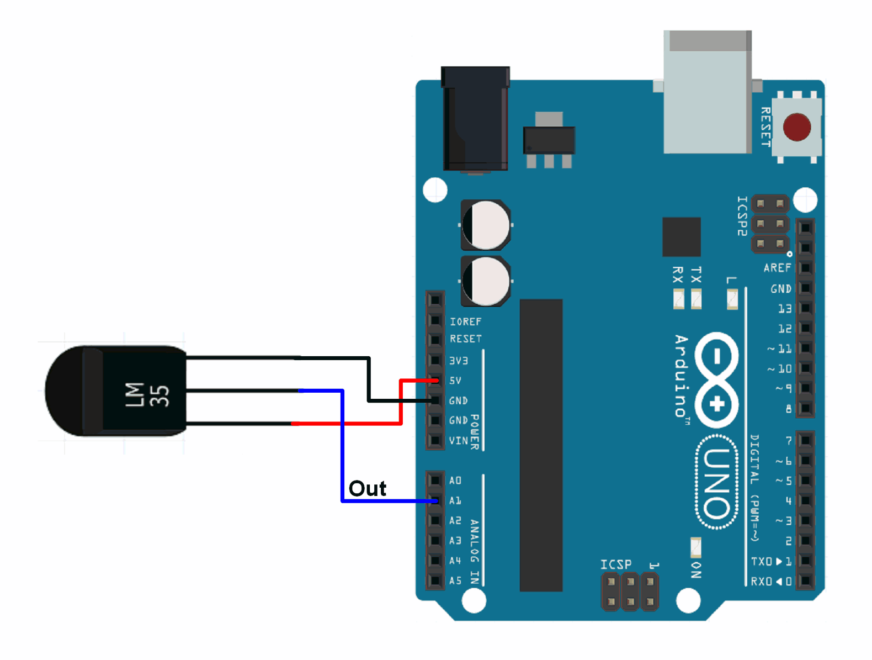

**LM35 Data sheet (Precision Centigrade Temperature Sensors)**

**General Description**

* The LM35 series are precision integrated-circuit temperature sensors, whose output voltage is linearly proportional to the Celsius (Centigrade) temperature.
* The LM35 thus has an advantage over linear temperature sensors calibrated in ° Kelvin, as the user is not required to subtract a large constant voltage from its output to obtain convenient Centigrade scaling.
* The LM35 does not require any external calibration or trimming to provide typical accuracies of ±1⁄4°C at room temperature and ±3⁄4°C over a full −55 to +150°C temperature range.
* Low cost is assured by trimming and calibration at the wafer level. The LM35’s low output impedance, linear output, and precise inherent calibration make interfacing to readout or control circuitry especially easy.
* It can be used with single power supplies, or with plus and minus supplies. As it draws only 60 μA from its supply, it has very low self-heating, less than 0.1°C in still air.
* The LM35 is rated to operate over a −55° to +150°C temperature range, while the LM35C is rated for a −40° to +110°C range (−10° with improved accuracy).
* The LM35 series is available packaged in hermetic TO-46 transistor packages, while the LM35C, LM35CA, and LM35D are also available in the plastic TO-92 transistor package.
* The LM35D is also available in an 8-lead surface mount small outline package and a plastic TO-220 package.

**LM35 Features**

* Calibrated directly in o Celsius (Centigrade)
* Linear + 10.0 mV/oC scale factor
* 0.5oC accuracy guaranteeable (at +25oC)
* Rated for full −55o to +150oC range
* Suitable for remote applications
* Low cost due to wafer-level trimming
* Operates from 4 to 30 volts
* Less than 60 µA current drain
* Low self-heating, 0.08oC in still air
* Nonlinearity only ±1⁄4oC typical
* Low impedance output, 0.1 Ω for 1 mA load

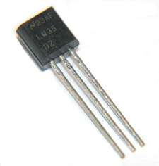

LM 35

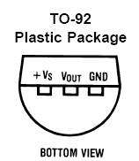

LM35 pin configuration

Code explanation

LM35 sensor has three terminals - Vs, Vout and GND. We will connect the sensor as follows −

* Connect the +Vs to +5v on your Arduino board.
* Connect Vout to Analog0 or A0 on Arduino board.
* Connect GND with GND on Arduino.

The Analog to Digital Converter (ADC) converts analog values into a digital approximation based on the formula ADC Value = sample * 1024 / reference voltage (+5v). So with a +5 volt reference, the digital approximation will be equal to input voltage * 205

Ouput

